Instruction Manual for Smart Force Dial
No.: TP6066
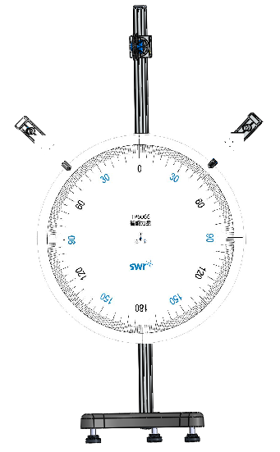
Product description
Pulley
Support rod
Support base
Support rod
Dial
- Function
Explore the parallelogram law in force composition and decomposition.
- Feature
This experimenter is easy to assemble. It can directly compose and decompose force with dipmeter. It has scale for easily analyzing and understanding experiment results. Its pulley helps explore forces in different directions.

Product description
No. | Name | Picture | Qty. | Remark
1 | Main body | 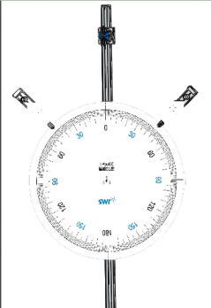 | 1 set
2 | Support base | 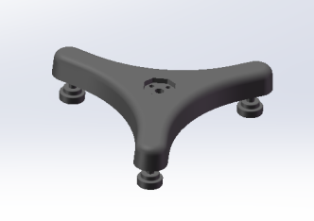 | 1pcs
3 | Hook weights | 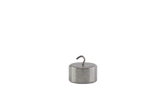 | 2 pcs | 50g
4 | Connecting line | 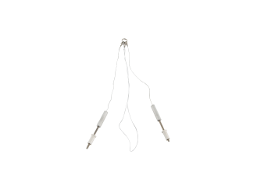 | 1set | Dipmeter, 2  Lobster clip, 3  Thread for weights,1
5 | Plum screw, black |  | 2 pcs | M6*25
6 | T-shaped handle | 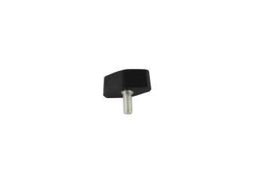 | 1 pcs | M6*15
7 | USB cable | 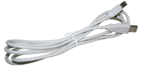 | 2 pccs

Adaptive sensor
- Dipmeter

Sensor parameter
Range: -20N~20N/0~180°
Resolution: force: 0.01N, average angle: 0.03°
Accuracy: ±1%F.S
- SWR iLab v8.0
Prompt:
Tighten the screws for fixing dipmeter. The thread hanging the weights should coincide with the 0°or 180° scale line. The middle ring should align with the dial dot.
Compatible software

Product using
- Assembly
Fix the pulley at the top of the support rod and fix the dial under the pulley. Connect the support base and rod. Install the two dipmeters on the support rod at both sides. After assembly, hang the hook weights on the thread.
- Experiment
- Explore the parallelogram law in force composition: hang the weights (with known mass) at the low end of the thread and fix it at a position on the rod. Then adjust the position of another rod. Users can obtain and analyze the value and direction of a force through value and direction of the other force.
- Explore the parallelogram law in force decomposition: hang the weights (with known mass) at the thread and adjust the positions of both rods. Users can determine the force values and directions of two rods and analyze the two decomposed forces to get the experiment results.
Maintenance

- When not in use, place the demonstrator in the carton and wipe the dust on its surface with a cloth.
- Keep the inside of experimenter clean and keep the whole in dry environment for maintaining its metal parts.

