Instruction Manual for Earthworm Motion Speed Demonstrator
No.: TP6060

Charging port
Built-in photogate-2
Track

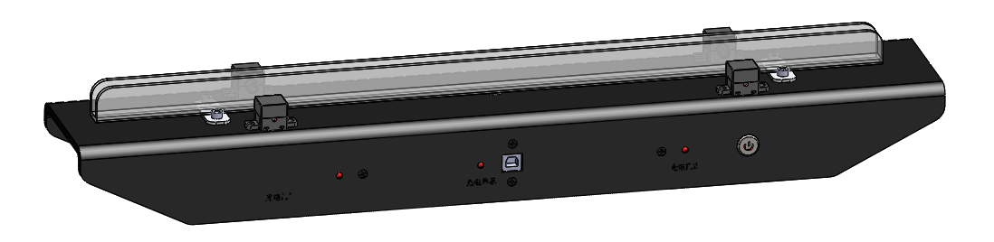
Indicator for photogate-2
Built-in photogate-1

Indicator for photogate-1

Product description
- Function
This product measures the earthworm speed on different contact surfaces with the built-in photogates.
- Feature
- Controllable earthworm crawling direction and distance, easily timing methods, which are not solved by traditional experimenters.
- This product is an integrated design which has built-in photogates. It can conveniently measure the earthworm motion time.
- The open track keeps the one-way crawling of the earthworm. Users can observe earthworm body when crawling.
- This product is equipped with three different contact surfaces and a blank track for users exploring by themselves.
- This product has Bluetooth function which helps to complete experiments wirelessly.
- This product fully meets the teaching requirements. Users can obtain the obvious effects with easy operations.

Product Specification
No. | Name | Picture | Qty. | Remark
1 | Main body | 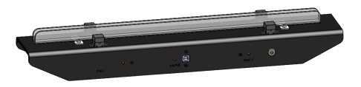 | 1set | With 3 contact surfaces
2 | Tweezers | 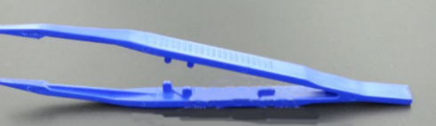 | 1pcs
3 | Textured paper | 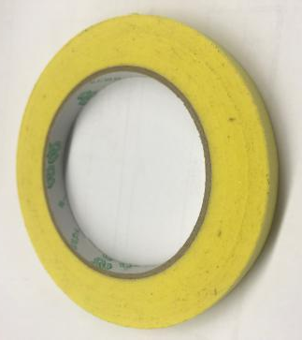 | 1roll
4 | Tape | 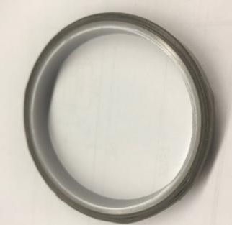 | 1roll
5 | USB cable | 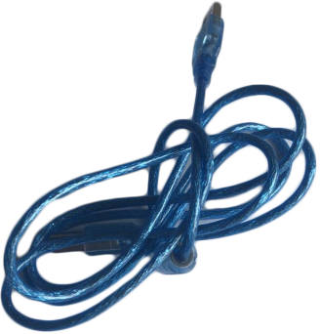 | 1pcs
6 | Bluetooth adapter 2.0 | 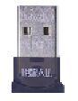 | 1pcs
7 | Brush |  | 1pcs | For cleaning tracks
8 | Power adapter | 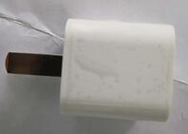 | 1pcs | 5V/1A
Adaptive sensor
- Photogate, 2 (built in)

Product Parameter
Sensor:
Range: 0~∞s
Accuracy: ±1μs
Resolution: 1μs
Battery (Lithium battery, rechargeable):
Working voltage: 3.7V
Full power standby: 14h
Compatible software
- SWR iLab v8.0
Note:
Please refer to the software instruction manuals for detailed installation method.
- SenseDisc iLab v10.0

Product using
- Connect the demonstrator with choosing the connection method (by Bluetooth or USB cable) and design a suitable experiment template (PC).
- Use tweezers to put an earthworm on the track and wait for it calming down.
- Open the template you designed, click Manual to acquire data, then analyze. In experiment, the time the earthworm passes through the first photogate is the starting time and the time it passes through the second one is the finishing time.
- During the earthworm motion, it is necessary to reduce the influence of unrelated factors. The earthworm can be wetted before experiment. The human factor should be reduced when replacing the track.
Risk warning

- It can seriously reduce the service life of the equipment when using in damp, corrosive gas, high temperature and other harsh environment.
- Be sure to remove the charger within 4 hours after full charge, so as not to affect the battery life.
- When the equipment power is low, please charge in time to avoid long time in low battery status.
- In case of any failure, please contact our company immediately. Do not disassemble the battery, disassemble the battery and use the sharp tool to penetrate the battery.
- If the device is not used for a long time, it should be charged every 3 months.
- When the temperature rise or other suspicious phenomenon is found in the use of electrical equipment, the power outage will be stopped immediately.
Maintenance

- Wash the track after experiment and dry it. Put it back in the carton.
- When not in use, place the demonstrator in the carton and wipe the dust on its surface with a cloth.

