Instruction Manual for Archimedes' Law of Flotation Demonstrator
Product No.：TP6028
- Description
The product consists of adjustable iron stand, tray, weight, water spilling bottle, measuring glass, hand screw and wing screw. It is used to explore the buoyancy applied on an emerged object is equal to gravity of water it ejected. It is practical and easy to operate.
- Product Specification
No. | Name | Picture | Quantity | Remark
1 | Adjustable iron stand | 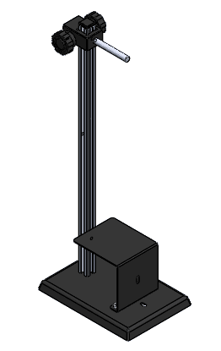 | 1 set | 200*150*500mm
2 | Tray | 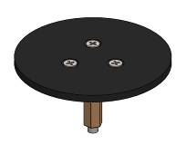 | 1 set | Φ60*33mm
3 | Weight | 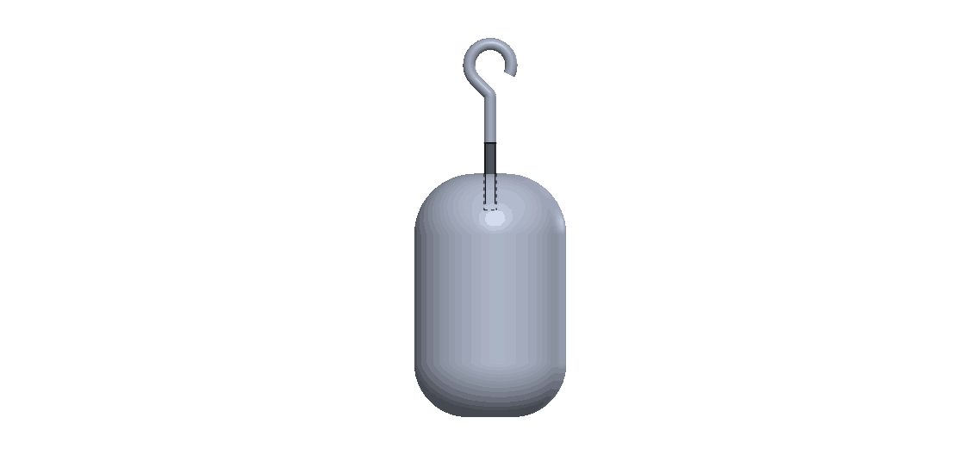 | 1 set
4 | Water spilling bottle | 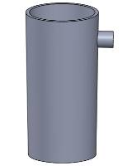 | 1 piece | 250ML
5 | Measuring glass | 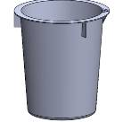 | 2 pieces | 150ML
6 | Plum screw | 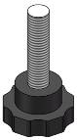 | 1 piece | M6x25
7 | Wing screw | 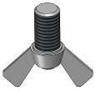 | 1 piece | M6x10
Tab.1
- Product General Assembly Figure
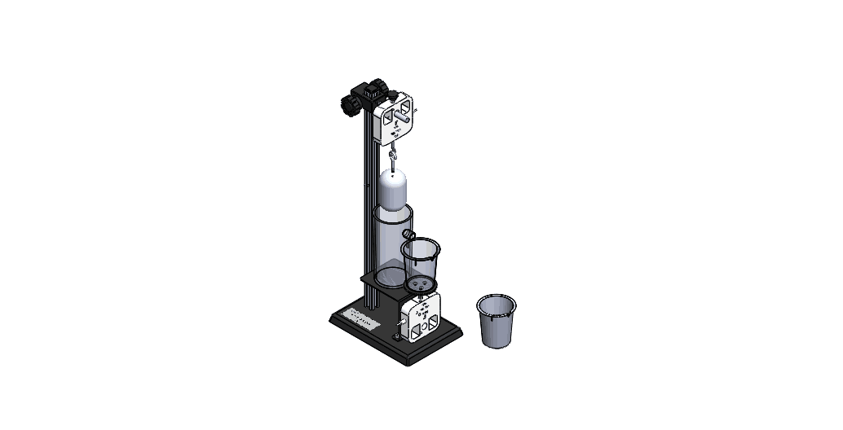
Fig.1
- Product General Assembly Procedures
There are two force sensors required for this experiment. One of them should be mounted on the upper side of adjustable iron stand and the other one’s hook should be replaced by tray. Mount the second sensor on the lower side of adjustable iron stand which is near to the shaft. Place weight, water spilling bottle and measuring glass according to Fig.1.
- Experimental Case
Experiment name
Buoyancy Law (Archimedes' law)
Experimental aim
To understand the buoyancy applied on an emerged object is equal to gravity of water it ejected.
Experimental equipment
Computer, Archimedes' law of flotation Demonstrator, SenseDisc and two force sensors.
Experimental procedures
Preparation:
1. As shown in Fig.1, assemble the demonstrator. Mount force sensors and SenseDisc on rod and shaft of adjustable iron stand.
2. Open experiment software  and select to open experiment menu.
3. Select at right upper corner.
4. Select in the experiment menu to create experiment template (Click  to read experiment guide).
5. Click ‘Calibrate’ to calibrate two force sensors.
Experiment:
- Hang the weight, place measuring glass and pour water into water spilling bottle according to Fig.1.
- Click ‘Record’ once data becomes stable. Record the value of weight and beaker.
- Immerse some part of weight into water. Wait until data becomes stable. Click ‘Record’ to record measured data.
4. Gradually increase the volume that the weight gets immersed. Record the measured data.
5. Compare the buoyancy applied on weight and gravity of water ejected.
6. Click ‘Figure’ to explore the figure of buoyancy applied on weight and gravity of water ejected. Analyze the experimental result.
7. Click ‘Clear’ to clear data if you need to restart experiment.
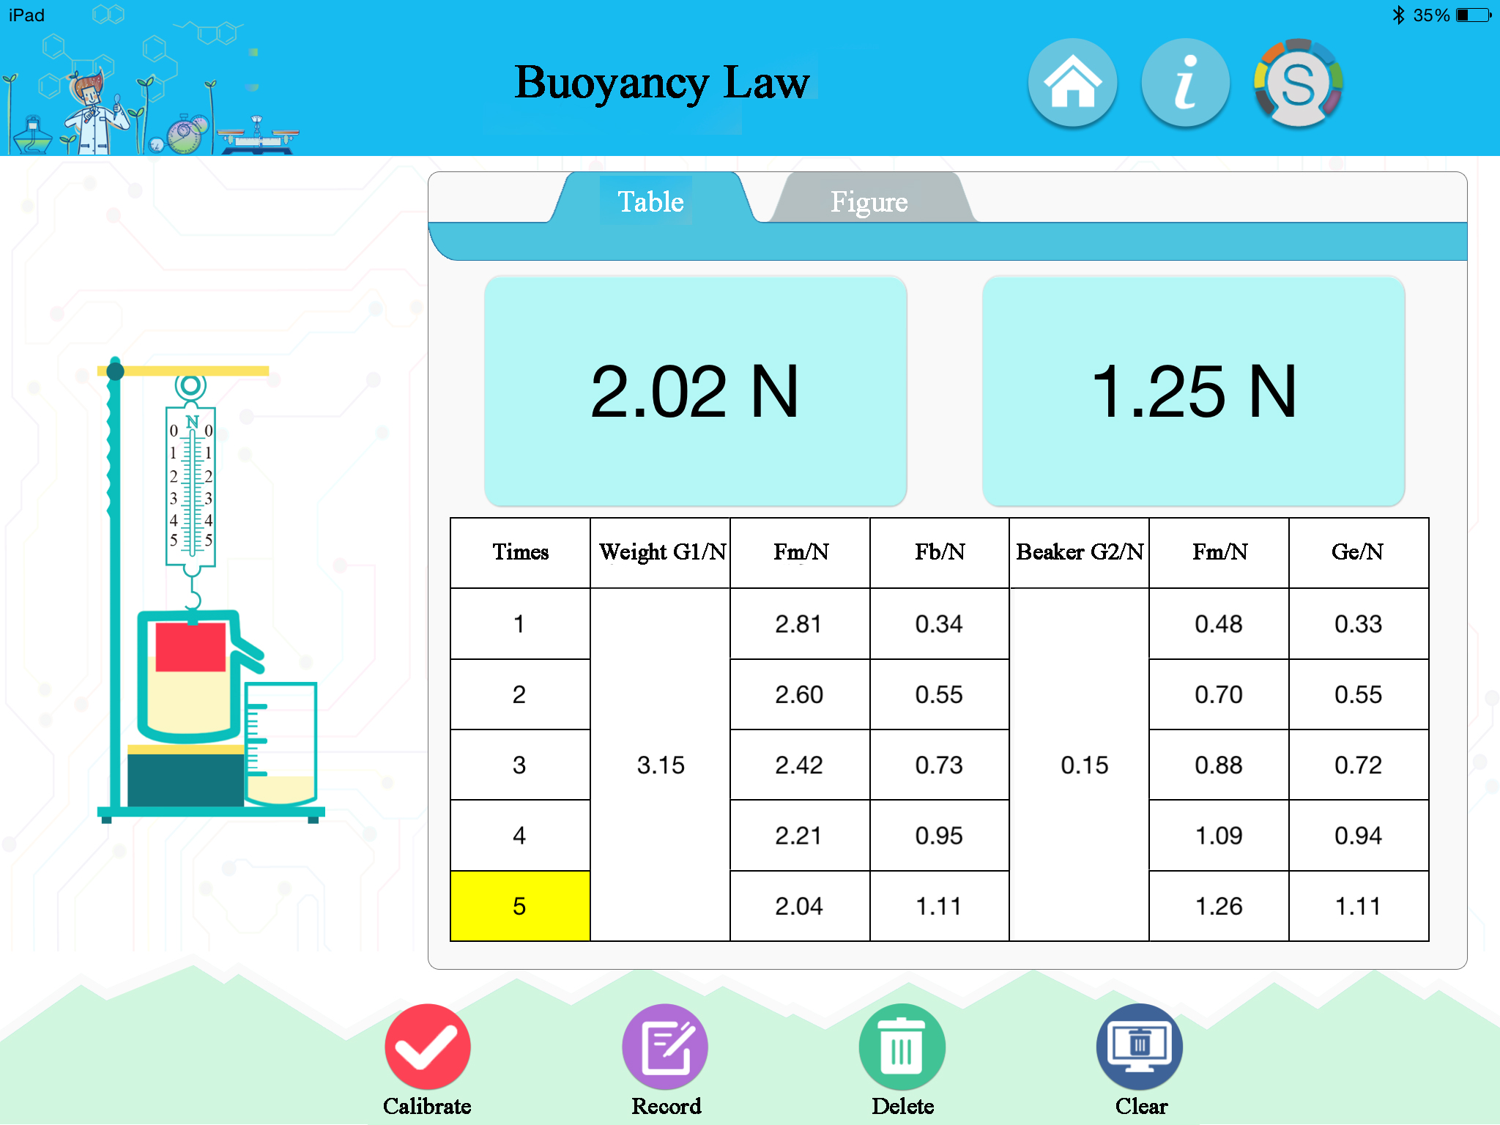
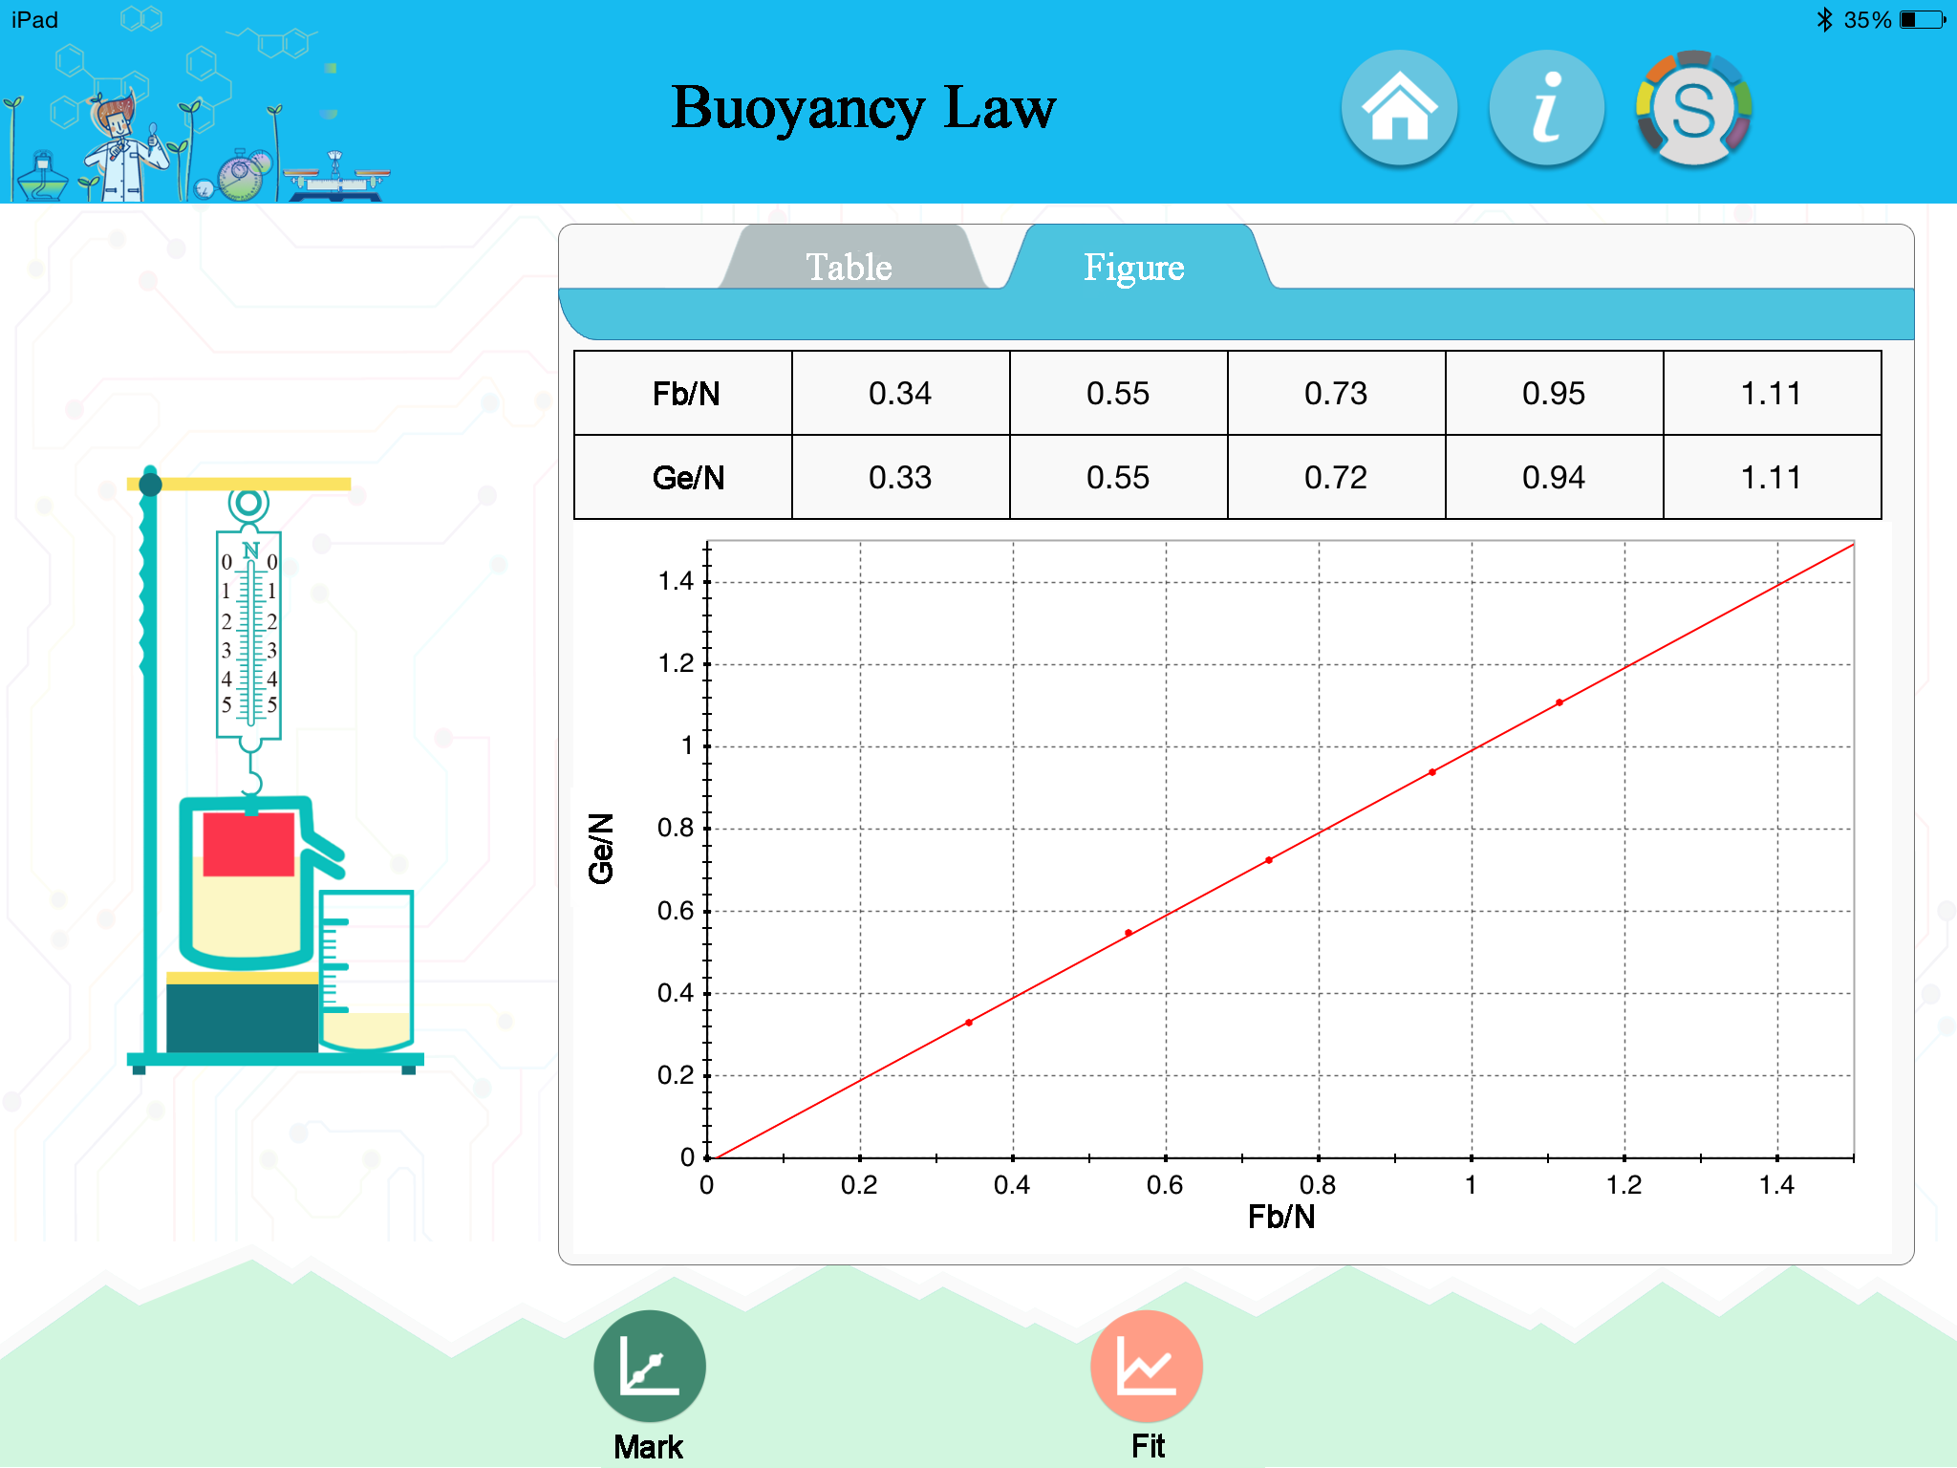
Fig.2: Experimental Result
- Notes
- Before experiment, calibrate both force sensors without weight and measuring glass.
- Before experiment, pour water into water spilling bottle until the water just spills out.
- Try to immerse the weight carefully and slowly. Otherwise extra water may eject and cause measuring error.
4. The accuracy of force sensor is 0.03N.
- Operating System
Connection | Support wire and wireless connection.
Supported system | Windows xp and above, iOS 8.0 and above, android 2.0 and above.

- Maintenance
The device should be placed in a cardboard box if not in use. Use a damp cloth to wipe out the dust on the surface lightly. Avoid scratches caused by sharp articles on the surface.

