Instruction Manual for Digital Friction Demonstrator
Product No.：TP4006
- Description
The product consists of control unit, track, cart and power adapter. It is used to explore factors affect friction. The product design meets the teaching requirements. It is easy to operate and practical.
- Product Specification
No. | Name | Picture | Quantity | Remark
1 | Control unit | 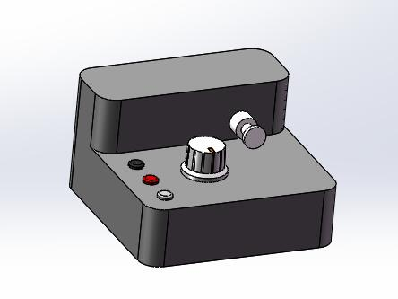 | 1 piece | L*W*H:107x104x62mm（with fishing line, lobster clip）
2 | Track 1 | 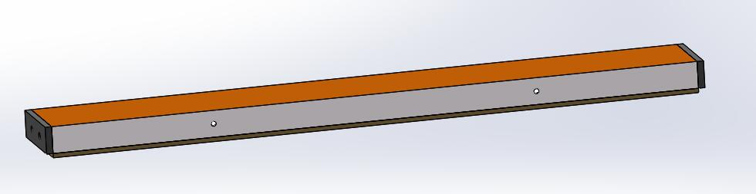 | 1 piece | L*W*H:600x80x30mm（including wood board, magnet）
3 | Track 2 |  | 1 piece | L*W*H:600x80x30mm（including wood board, magnet）
4 | Cart | 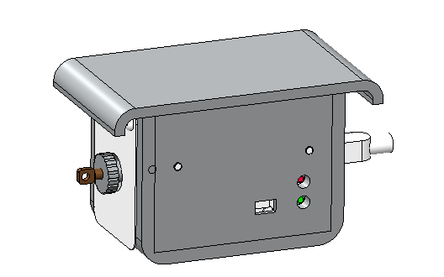 | 1 piece | 105x60x65mm  (around 388g)
5 | Power adapter | 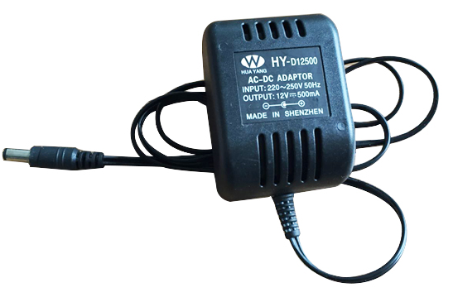 | 1 piece | DC 12v 500mA
6 | USB cable | 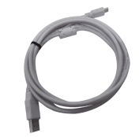 | 1 piece
7 | Weight | 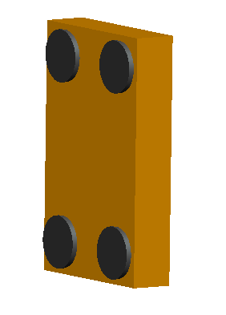 | 1 piece | Ø15x1mm（with gum mat）
8 | Bluetooth adapter | 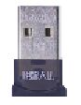 | 1 piece
Tab.1
- Product General Assembly Figure
Control unit
Cart
Track
Weight
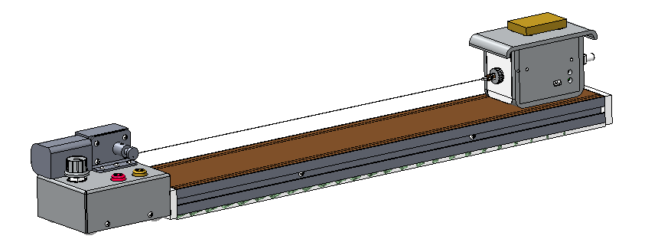

Fig.1: Product General Assembly
- Product General Assembly Procedures
1. Put the control unit on the track. Keep them touching tightly and level.
2. Connect the control unit and the cart by using string and hook provided in the bundle. Control unit will pull the cart.
3. Connect the power adapter and control unit.
- Experimental Case
Experiment name
Explore the relationship between friction and roughness of touching surface and mass of cart.
Experimental aim
To explore the relationship between friction and roughness of touching surface and mass of cart.
Experimental principle
The control unit pull small cart to move uniformly and linearly. The built-in force sensor in small cart is able to measure friction under any condition.
Experimental apparatus
Computer, primary science SenseDisc, the new iLab (primary experiment software) and digital friction demonstrator.
Experimental installation figure

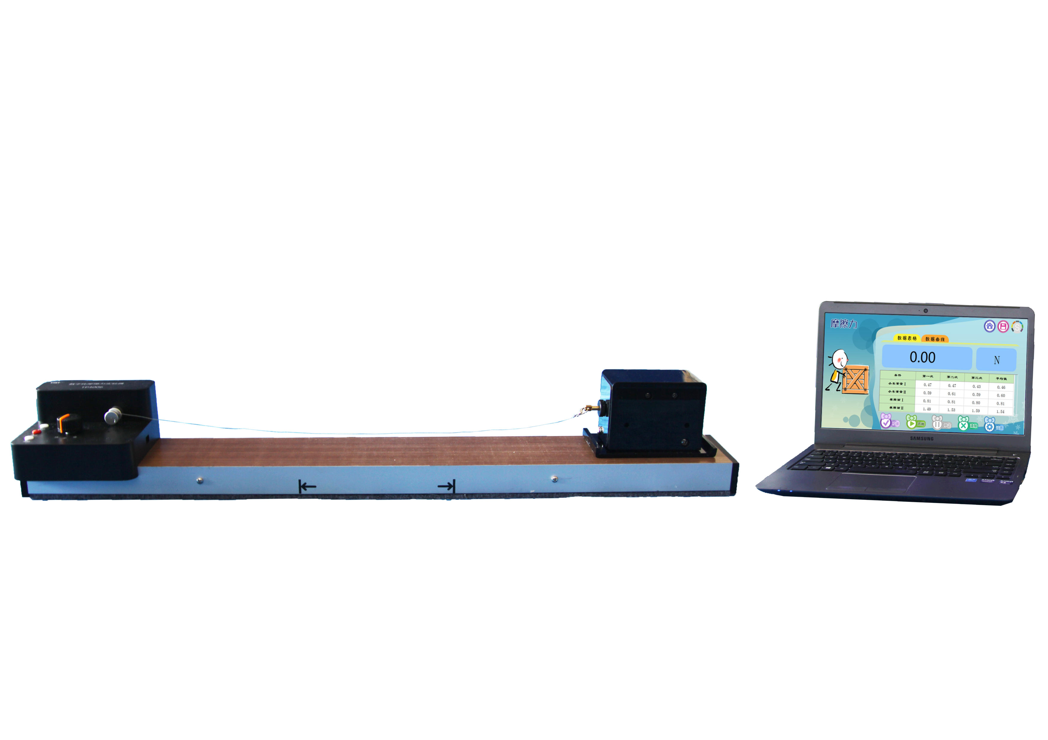
Fig.2: Experimental Installation
- Experimental Procedures
1. Set up the apparatus according to Fig.2.
2. Open the experiment software and click  to open experiment menu.
3. Click 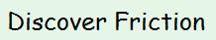 in the experiment menu to create experiment template.
4. Click  to tick the factors.
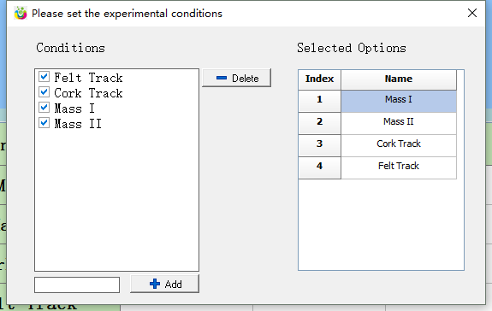
5. You can also edit and add customize factors at . Select a factor and click to delete it. Click to close the ‘set’ window.
6. Click  to calibrate force sensor.
7. Click  and turn on the control unit to pull the small cart. Once it arrives the end of track, it will stop moving automatically. The software will automatically stop at the same time and note experiment data.
8. Repeat three times for same factor and the average value of result will be calculated by the software.
9. Repeat the procedures mentioned above with different factors to explore the relationship between friction and roughness of touching surface and mass of cart.
10. You can click  when you make any mistake to stop the experiment. Also, you can select one data and click  to delete it.
Experimental result
According to the experimental result, friction is direct proportional to mass of cart. You can explore how other factors affect friction.
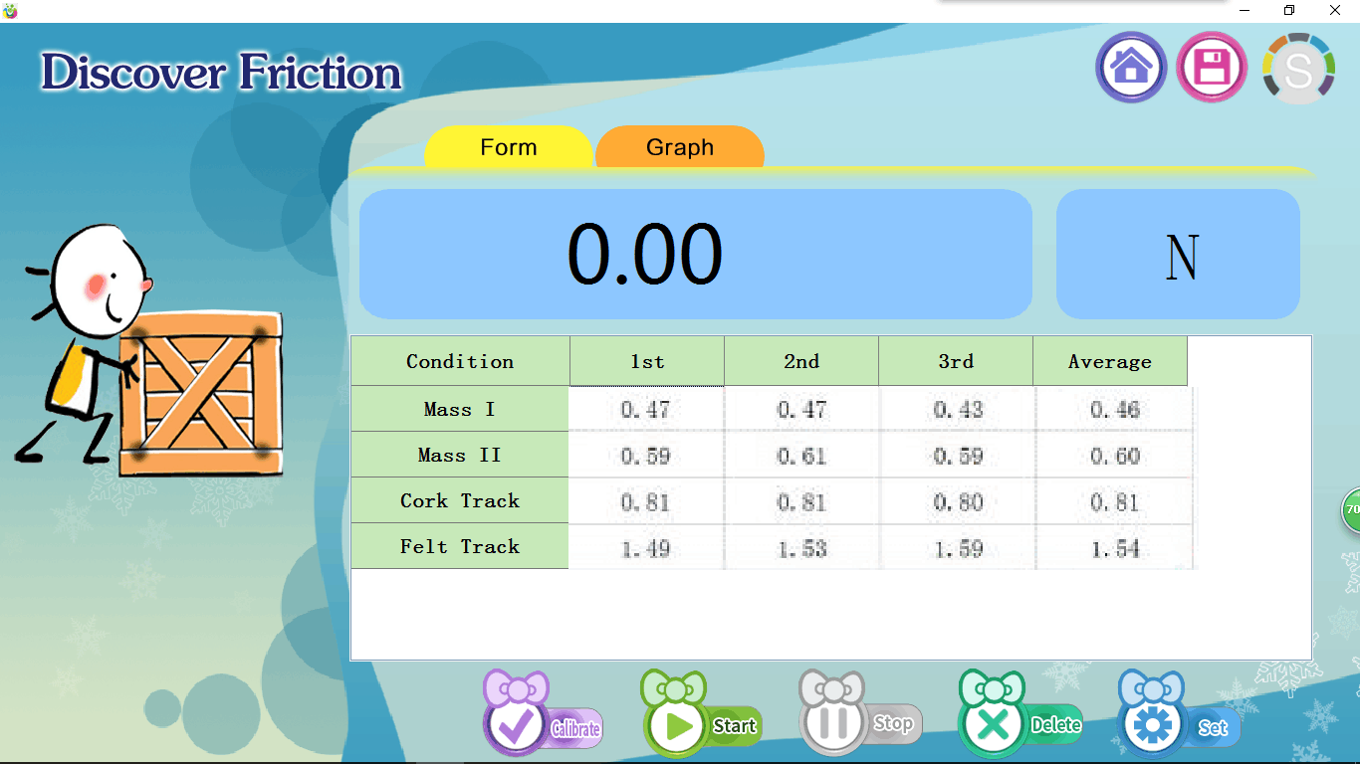
- Notes
1. Connect the power adapter and the control unit first. Switch on the circuit. Be careful when you are using the electric device.
2. Be careful when you are using the track because the sharp corner of the track may cause damage.
- Maintenance
1. When not in use, the apparatus should be placed in a cardboard box and wipe dust on the surface lightly with a damp cloth.
2. Gently use the track. Avoid any collision caused by other objects to damage the track surface.
3. After using cart, turn off Bluetooth in order to minimize the power consumption.

