Instruction Manual for Joule's Law Demonstrator
Product No.: TP4005
- Description
This product consists of PCB, rubber stopper and baseplate. It can be used to explore the Joule's law. It is used with temperature sensor to measure the relationship between current heating effect and amplitude of the current.
- Product Specification
No. | Name | Picture | Quantity | Remark
1 | PCB | 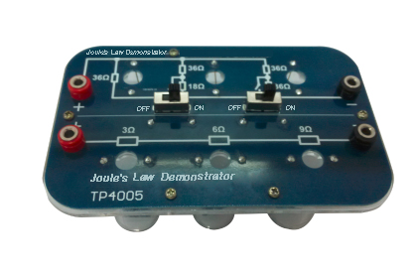 | 1 piece
2 | Rubber stopper | 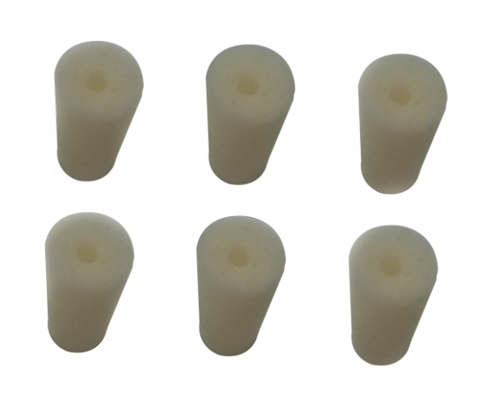 | 6 pieces
3 | Baseplate | 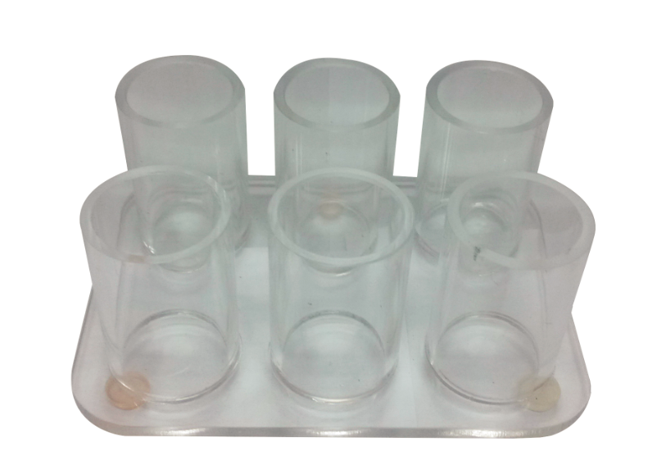 | 1 set
Tab.1
- Product General Assembly Figure
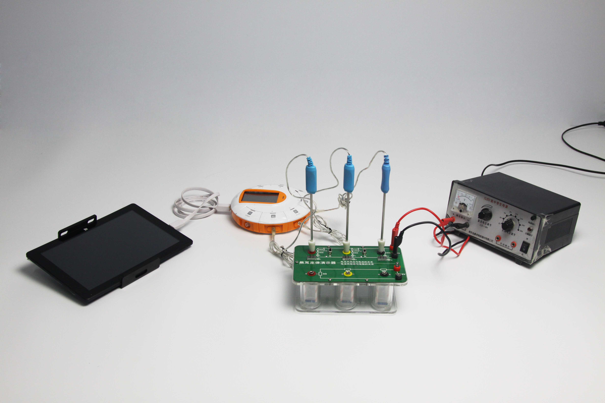
Fig.1: Joule's Law Demonstrator
- Product General Assembly Procedure
Assembly is not required, as shown in fig.1.
- Notes
1. Before the experiment, you should open the switch before connecting the circuit.
2. The output voltage should be adjusted from lower to higher and not more than 10V.
3. The proposed medium is oil. Use water may cause a short circuit.
- Maintenance
The device should be placed in a cardboard box if not in use. Use a damp cloth to wipe out the dust on the surface lightly. Avoid scratches caused by sharp articles on the surface.

