Instruction Manual for Digital Photoelectric Effect Demonstrator
Product No.： TP2602
- Description
This product consists of a digital photoelectric effect demonstrator, photocell cover, photocell, USB light bar and optical filters. It is used to explore photoelectric effect and verify saturated light current.
- Product Specification
No. | Name | Picture | Quantity | Remark
1 | Digital photoelectric effect demonstrator | 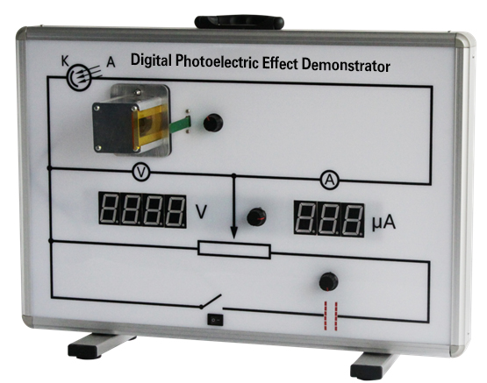 | 1 set
2 | Photocell cover | 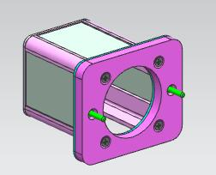 | 1 piece | 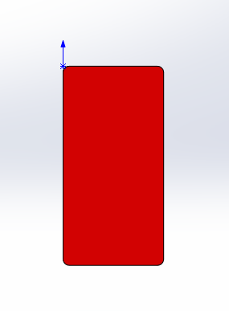  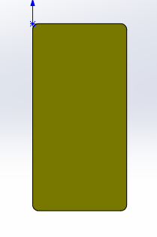  
3 | Photocell | 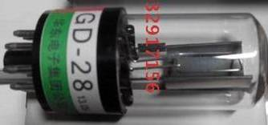 | 1 piece
4 | USB light bar | 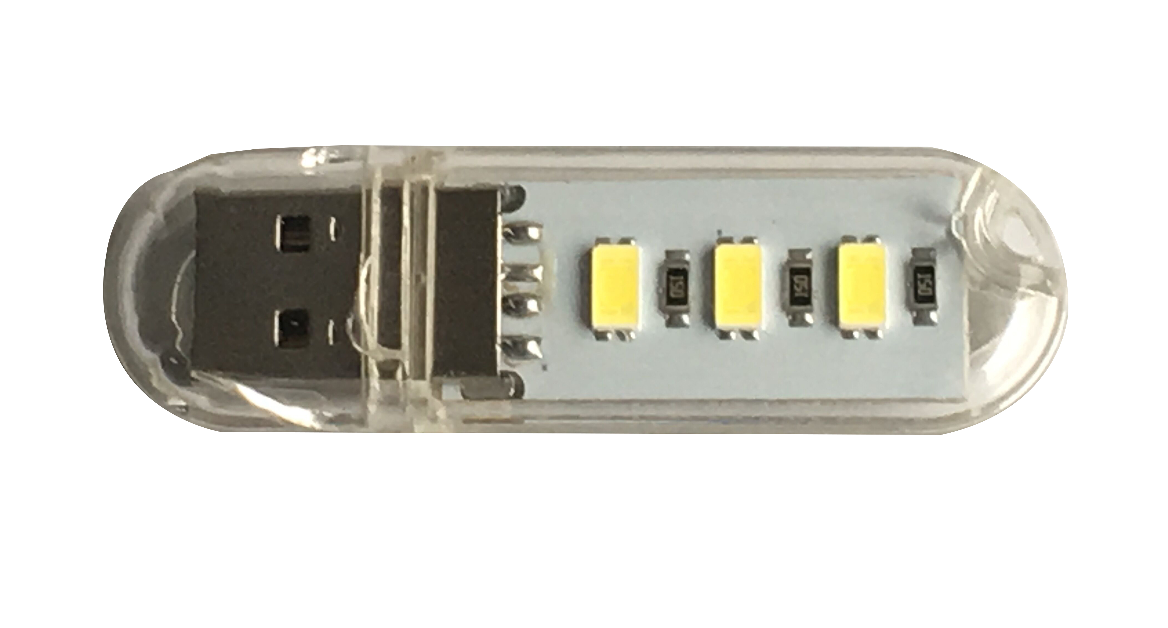 | 1 piece
5 | Optical filter |  | 3 pieces | One piece for each, red, yellow and blue 95*48*1.8mm
6 | USB cable | 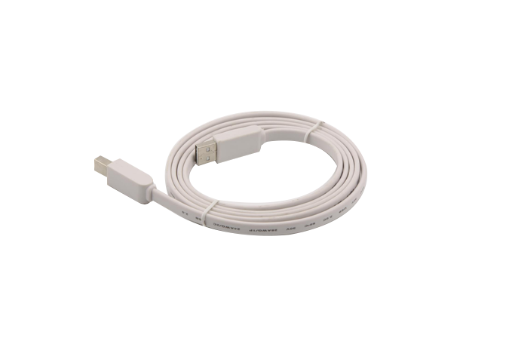 | 1 piece
7 | Power adapter | 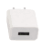 | 1 piece | 5V-1A
Tab 1
- Product General Assembly Figure
Fig.1 Product General Assembly
- Product General Assembly Procedures
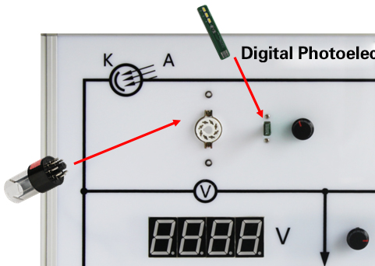
Fig. 2
Insert photocell and USB light bar into corresponding plugs on the demonstrator as shown in fig. 2.

Fig. 3
Mount the photocell cover over the photocell and insert optical filters into the slot shown in Fig. 3.
Before the experiment, connect the demonstrator to computer using USB cable.

- Maintenance
1. The device should be placed in a cardboard box if not in use. Use a damp cloth to wipe out the dust on the surface lightly. Avoid scratches caused by sharp articles on the surface
2. It is better to place desiccant in the cardboard box.

