Instruction Manual for Solar Cell
Product No.: TP2037
- Description
This solar cell consists of baseplate, holder, fixing board, panel and solar panel. It is mainly used to study the working principle of solar power generation and the factors affect it.
- Product Specification
NO. | Name | Picture | Quantity | Remark
1 | Solar cell | 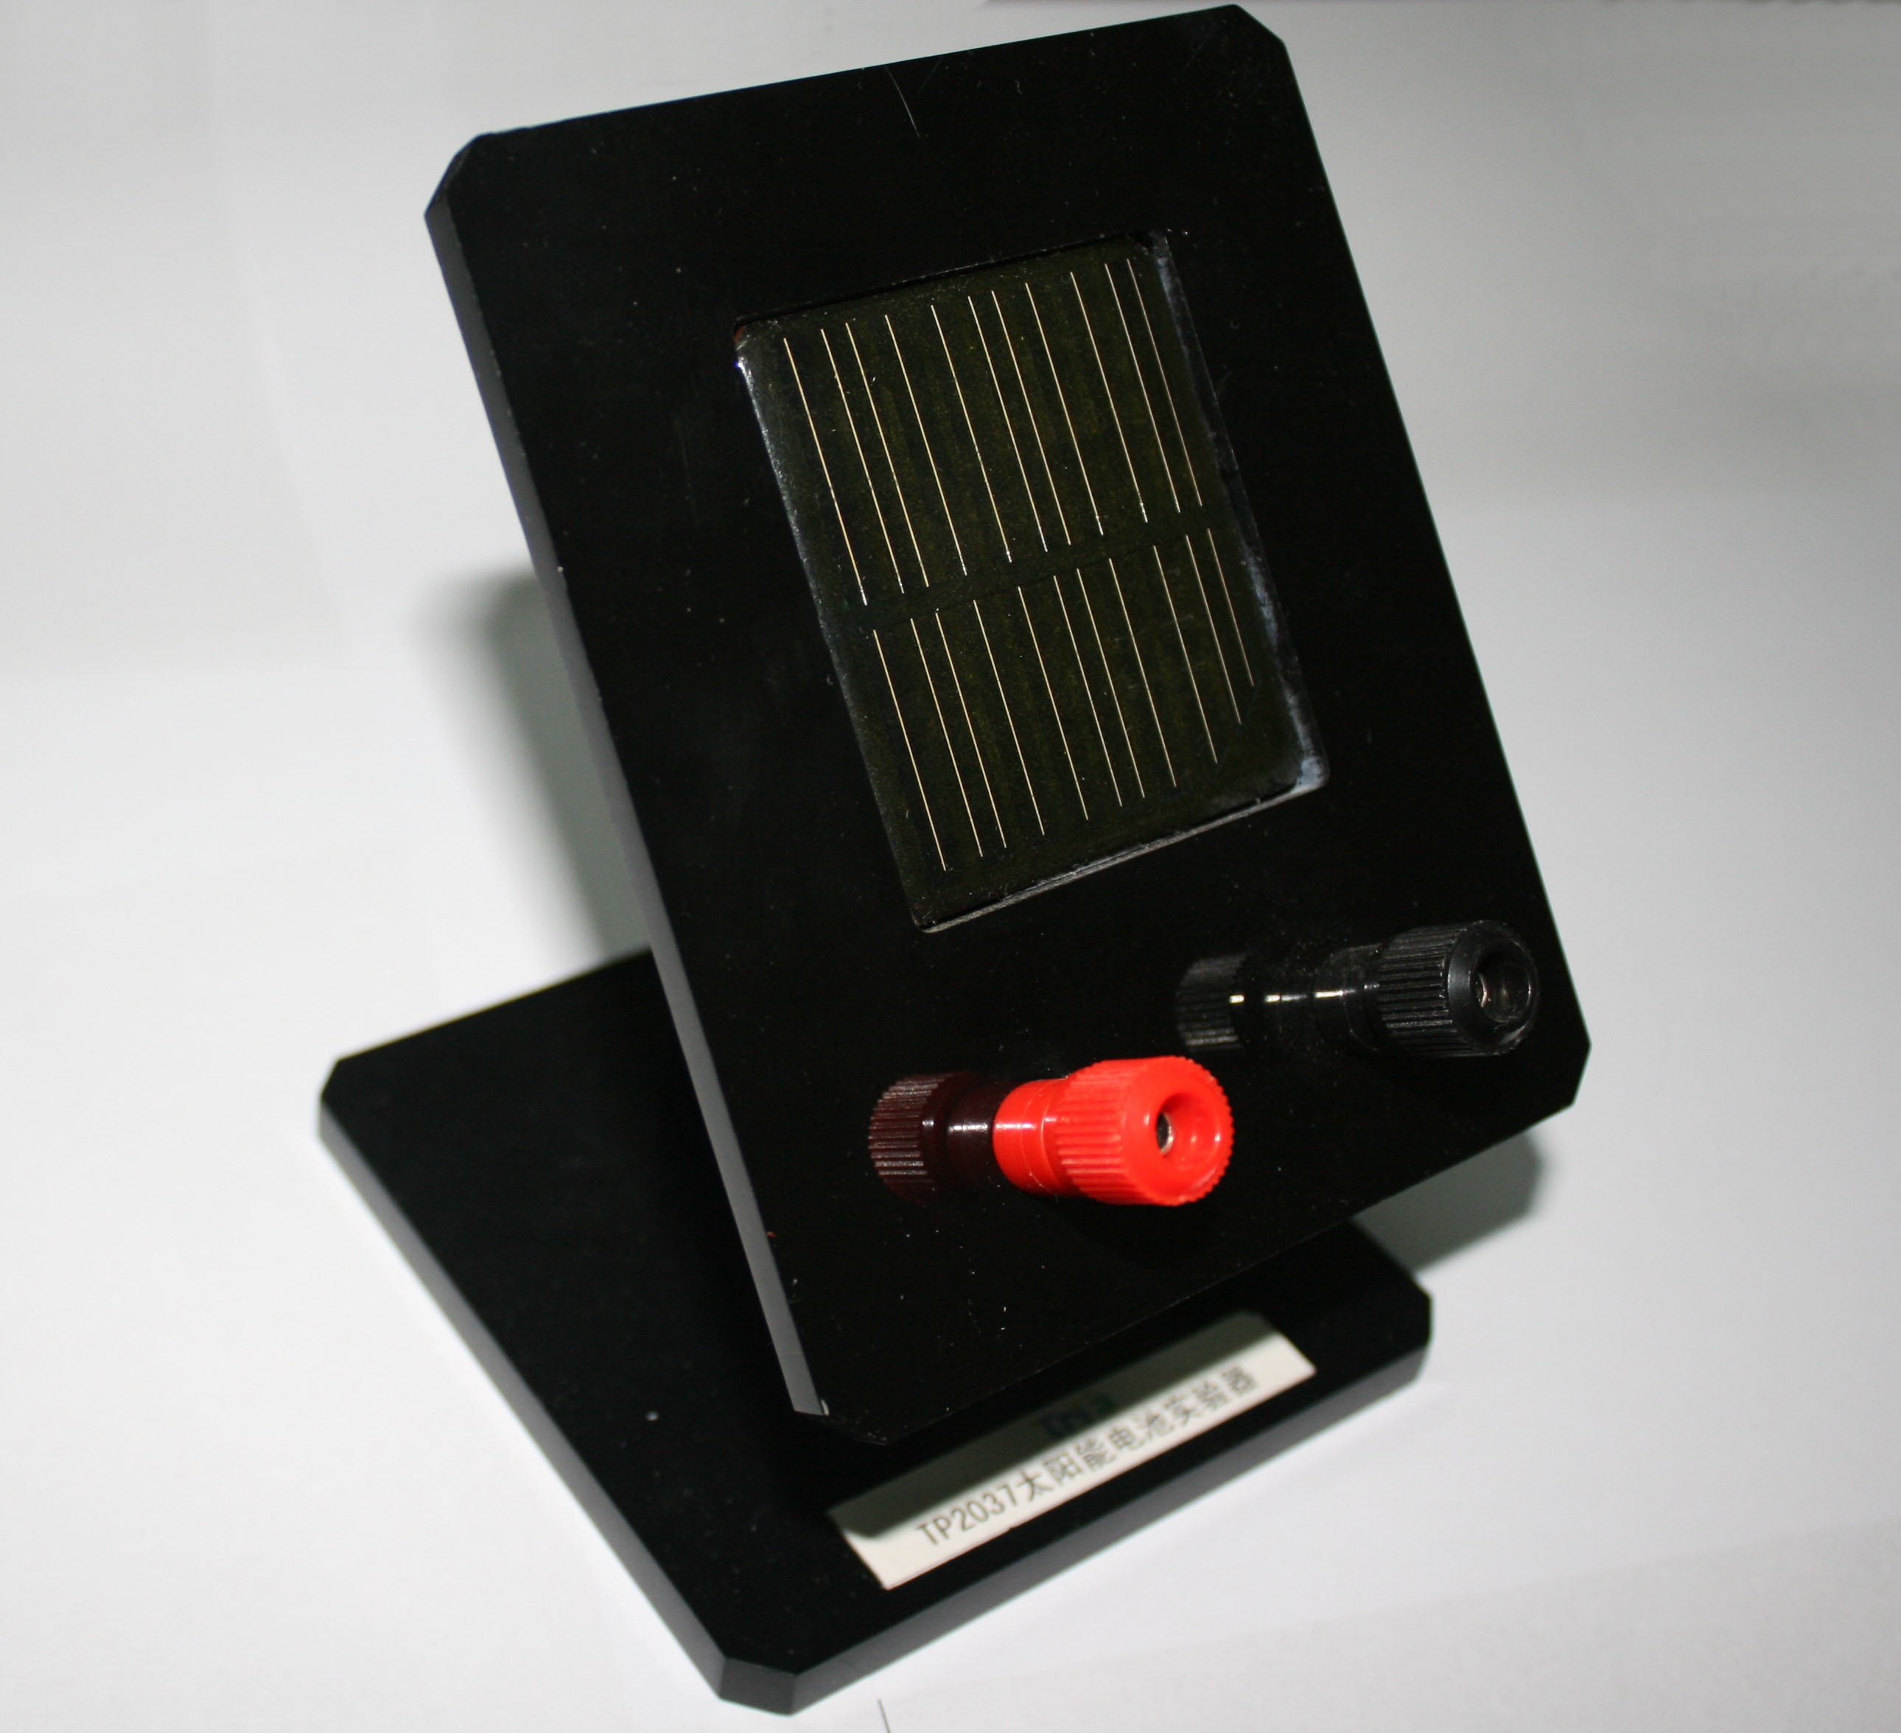 | 1 set
Tab. 1
- Product General Assembly Figure
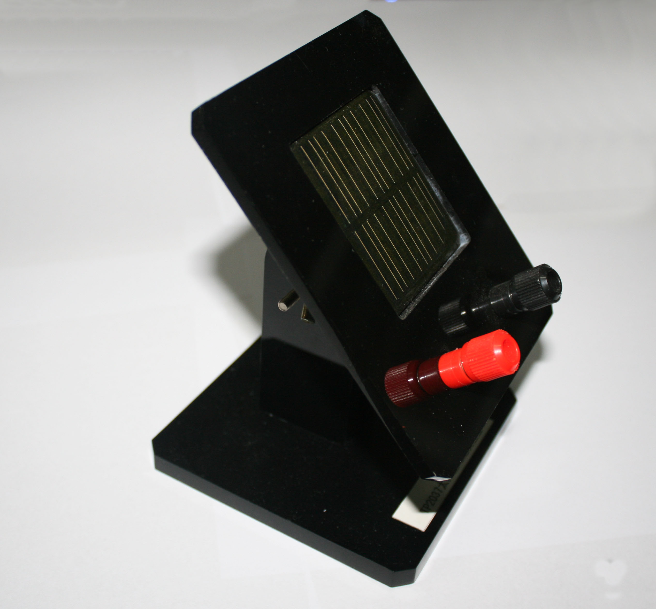
Fig. 1 Solar Cell
- Product General Assembly Procedure
Assembly is not required, as shown in Fig.1.
- Experimental Case
Experiment name
Solar cell
Experimental aim
To explore the working principle of solar power generation and the factors affect it.
Experimental principle
Solar cell is a kind of device which can be used to convert the sunlight into electrical energy directly through the photoelectric effect or photochemical effect. The sunlight is irradiated to the solar panel. Current will be produced. The current and voltage will vary with the changing of illumination.
Experimental apparatus
Computer, datalogger, solar cell, voltage sensor, data cable and light source
Experimental installation figure
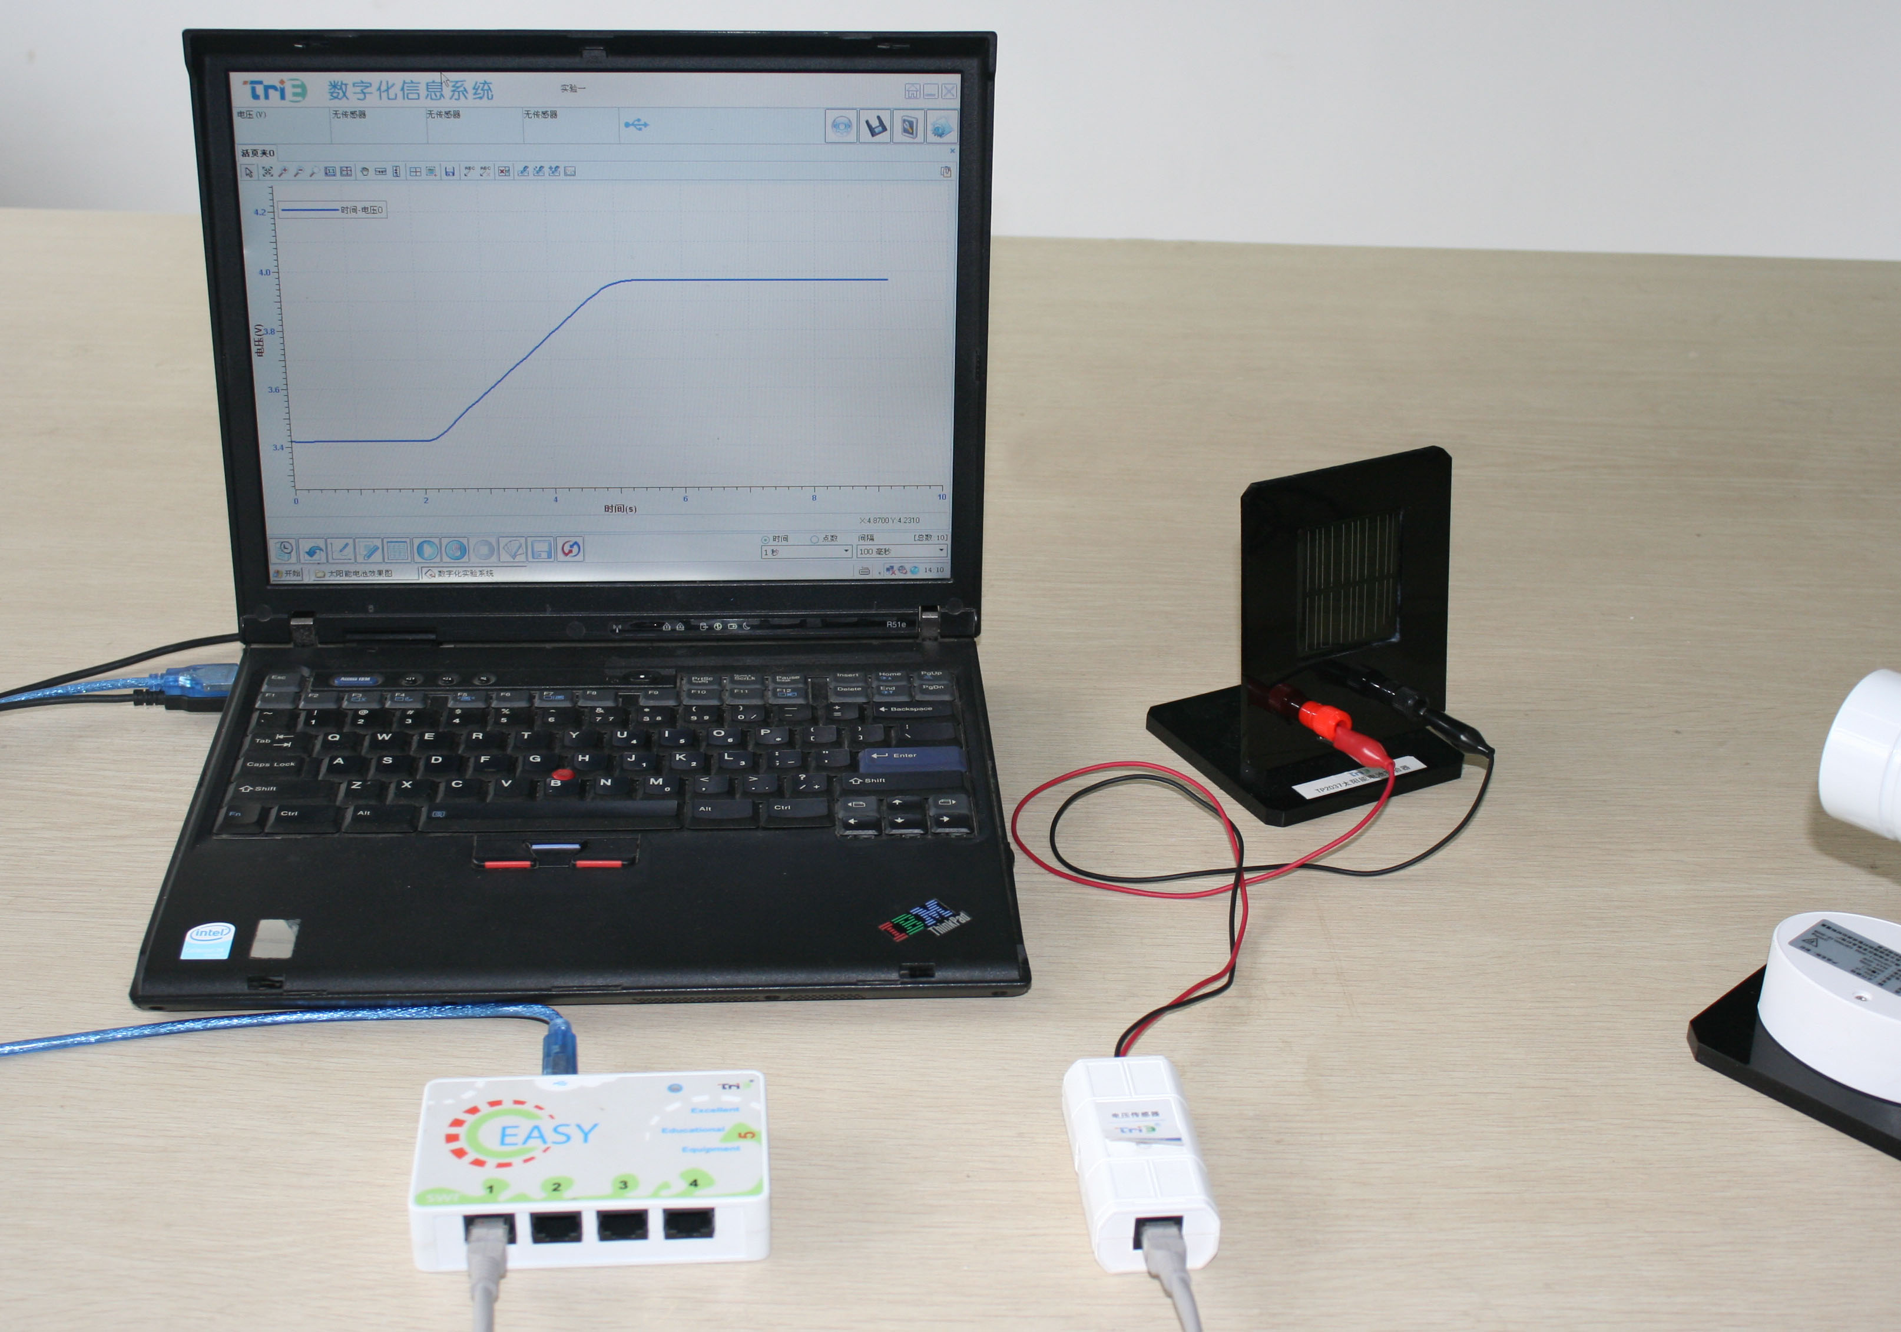
Fig. 2 Experimental Installation
- Experimental Procedures
1. As shown in Fig. 2, set up the experimental apparatus. Keep proper distance between the solar cell and the lamp such as 100cm.
2. Open the experiment software. Click ‘New’ and create the ‘Voltage-Time’ coordinate.
3. Short connect the voltage sensor to calibrate it. Connect the alligator clips to the red and black terminals. Choose the experimental time to 1 minute and the acquisition interval to 100ms.
4. Turn on the lamp. Adjust the angle of the solar cell panel. Click the ‘Start’ button. Hold the solar cell and move it to the lamp at a constant speed. Click the ‘Stop’ button after the acquisition is done.
5. Observe the curve of voltage varying with time.
6. Click the ‘Save’ button to save the experimental result.
- Experimental Result
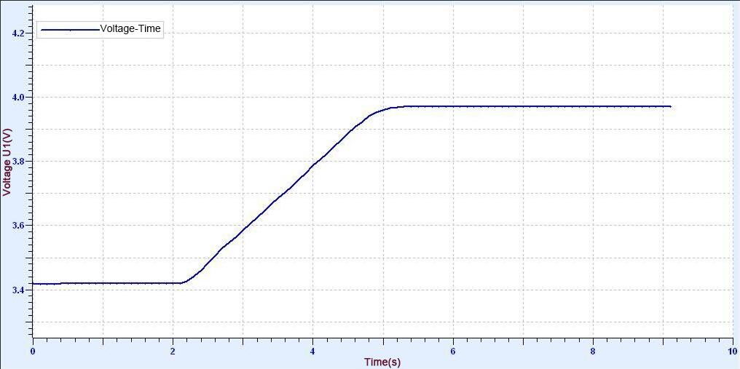
Fig.3 Experimental Result
- Notes
1. Before doing experiment, adjust the direction and angle of the solar cell and fix it well. The distance between the solar cell panel and the light source should be above 50cm.
2. When doing experiment, the working time of light source should not be too long. Do not touch the lamp. Be careful when taking out or putting down the instrument.
- Maintenance
The device should be placed in a cardboard box if not in use. Use a damp cloth to wipe out the dust on the surface lightly. Avoid scratches caused by sharp articles on the surface.

