Instruction Manual for Geomagnetic Field Generator
Product No.: TP2003
- Description
This product consists of blue square rotatable coil and baseplate. It is mainly used to explore the phenomenon that geomagnetic field generates electricity. This product is practical, simple and easy to operate.
- Product Specification
No. | Name | Picture | Quantity | Remark
1 | Square rotatable coil | 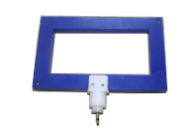 | 1 piece | Blue square coil and banana plug
2 | Baseplate | 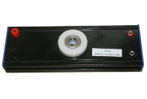 | 1 piece | Include red and black terminals
Tab. 1
- Product General Assembly Figure
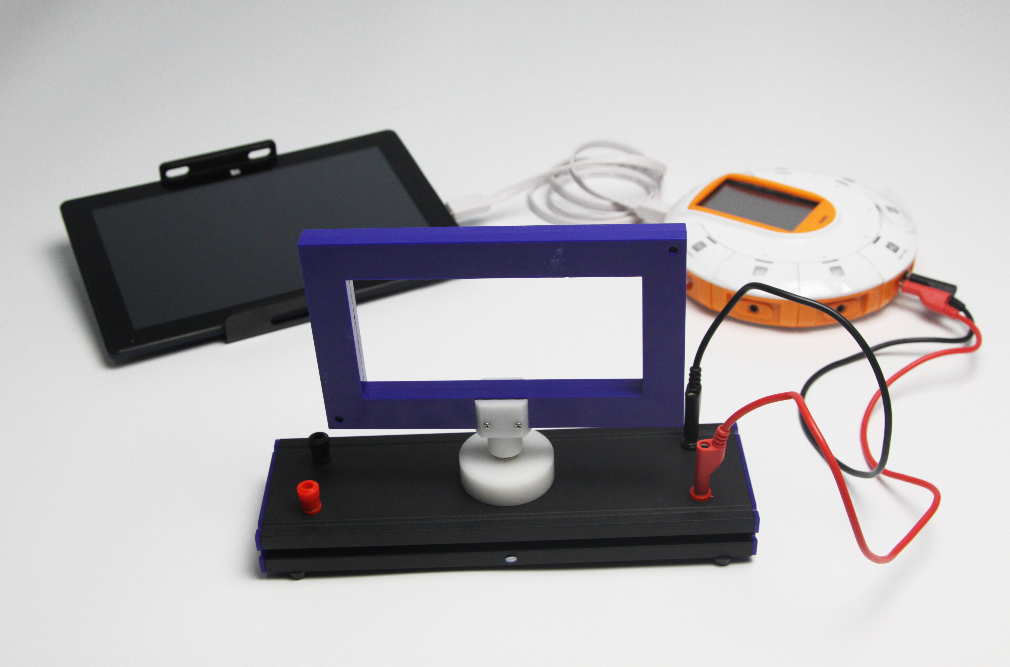
Fig.1: Geomagnetic Field Generator
- Product General Assembly Procedure
Insert the blue square rotatable coil into the socket of baseplate. The product assembly diagram is shown in Fig.1.
- Notes
When rotating the coil, do not overexert. Otherwise the coil may break away from baseplate.
- Maintenance
The device should be placed in a cardboard box if not in use. Use a damp cloth to wipe out the dust on the surface lightly. Avoid scratches caused by sharp articles on the surface.

